*Written Report Only*

**University of Missouri System Annual Benefits Report**

**April 2019**

This annual benefits report is provided to the University of Missouri Board of Curators pursuant to Section 520.010 of the Collected Rules & Regulations. The following highlights are included: changes in medical costs and contributions to the medical plans; current trends and market analysis for medical and retirement plans; and future steps to ensure competitive advantage for recruitment and retention of top talent.

The Total Rewards Advisory Committee (TRAC), comprised of a faculty and a staff member from each campus, a hospital representative and a retiree representative, continues to be actively engaged in benefit, retirement, compensation and policy analysis, discussions and advancements for the University of Missouri. It is through this valued and trusted partnership that TRAC has assisted in several major initiatives through input, support and feedback. Collaboration and shared governance between TRAC and Human Resources continues to be essential as we review benefit and retirement plan offerings in the years to come.

Contents

**I.** **Benefit Costs**

A. OVERVIEW

b. UNIVERSITY CONTRIBUTIONS TO BENEFIT PLANS

C. CHANGE IN BENEFIT COST ALLOCATION

**II.** **HEALTH BENEFITS**

A. OVERVIEW

B. CLAIMS AND PHARMACEUTICAL TRENDS

C. TOP FIVE COST DRIVERS IN 2018

D. KEY STEPS TO MANAGE PLAN COST

**III.** **PREMIUMS IMPLEMENTED IN 2019**

**IV.** **RETIREMENT PLANS FINANCIAL IMPACT**

**VI.** **STRATEGIC DIRECTION**

**VII.** **ATTACHMENTS**

A. BENEFIT SUMMARY PLAN DOCUMENT CHANGE COMPARISON 18-19

B. RETIREMENT, DISABILITY, AND DEATH BENEFIT PLAN ACTUARIAL REPORT

1. **Benefit Costs**
   * + 1. OVERVIEW

The primary drivers of the University’s benefit cost are retirement, medical, and retiree benefits, which account for nearly 92% of the total cost of benefits. Like many public sector employers, the University has experienced a steady increase in retirement and medical costs, which outpaces the growth in both revenues and salaries. Engaging TRAC, the University has taken proactive steps to continue managing the costs and sustainability of the benefits offered, while meeting current and future workforce needs.

* 1. UNIVERSITY CONTRIBUTIONS TO BENEFIT PLANS

The University makes employer contributions on behalf of employees into the benefit plans offered. Between FY2014 and FY2018, the University’s contributions were relatively steady. Contributions stabilized as a result of two factors: investment returns on the pension hovered around the discount rate but never fully recovered from the 2008 financial crisis. Additionally, the University implemented the Custom Network Plan which held down medical costs. However, the contributions will increase in FY19 and FY20 as a part of the University’s long-term plan to manage benefit liabilities.

For FY19, the contributions will increase by $34 million from FY18 and in FY20 are projected to increase by $11 million. The majority, $23 million, of the FY19 increase is driven by the decision to move the expected return assumption on the plan from 7.75% to 7.2%. Moving the expected return assumption down caused contributions into the plan to increase to fund future benefit payments. Increasing contributions into the pension plan is a key component of controlling growth in the University’s unfunded liability. Controlling the retirement plan cost and future liabilities is a key piece of the retirement plan redesign.

The other major cause of the increase in cost each year is driven by medical premium increases contributed to the University’s self-insured medical plans. Over the past five years, the University has experienced a 3% per covered member trend rate in medical benefit costs, well below the national average of 6%. The change in retiree healthcare offerings and the movement of employees into the Custom Network Plan drove most of the lower trend over the previous three years. However, that is not expected to carry forward into the future as the majority of eligible employees have migrated into the Custom Network Plan.

C. CHANGE IN BENEFIT COST ALLOCATION

For FY20, the University will change the way it allocates benefit costs to departments. In the past, the University utilized the “flat rate” to fund benefit plan contributions from budget holders. The flat rate was calculated as the total expected benefit plan contributions for the year divided by the total salaries of benefit-eligible employees for that year. Essentially, the flat rate assumed that salaries are the only driver of benefit costs. In reality, medical and dental benefits have no relationship with salary and represent roughly half of total benefit costs. To support better decision-making by budget holders, the University is implementing a two-component allocation process for benefits:

1. Retirement, Long Term Disability, Life Insurance and other benefits that are a function of salary will continue to be charged as a percentage of pay; and
2. Medical and Dental costs will be charged per benefit eligible employee, at a single rate for all employees.

The change in benefit cost allocation will have the following benefits:

* Helps managers understand that both size of workforce and workforce salary drive total compensation costs
* Decreases the incremental cost of giving raises (medical and dental costs no longer charged on salary)
* Provides the University with greater transparency on the types of benefit cost that increase

The change in the benefit rates is a part of the University’s annual budget process for FY20, and each University will address this change through that standard process.

1. **HEALTH BENEFITS**

* + - 1. OVERVIEW

The University offers a comprehensive set of benefit options with flexibility for employees to choose plans that are right for them and their families. Summary of plans include:

* The traditional PPO Medical Plan offers a broad network of providers, which may be ideal for those who desire flexibility for medical services at a higher cost.
* The Healthy Savings Plan is coupled with a Health Savings Account (HSA). The University makes an annual contribution to help increase employee savings for qualified healthcare expenses.
* The Custom Network Plan is available in eligible regions around Columbia and St. Louis. It offers a focused network of providers, which improves the quality of services and shared savings for those employees who are willing to limit their provider choices for a lower cost plan.
* The Tiered PPO Plan for Kansas City was featured in January 2018. This plan utilizes the same broad network as the traditional PPO Plan. However, it is designed to provide additional cost savings to employees who use providers recognized as offering high-quality and cost-effective care.
* Ancillary benefits such as dental, vision, life insurance, accidental death & dismemberment and long-term disability are available to employees.
* Employees may also participate in the Wellness Program, which focuses on promoting healthy workplace practices that encourage habits of wellbeing, inspire and empower individuals to take responsibility for their health and support a sense of community.

## CLAIMS AND PHARMACEUTICAL TRENDS

The cost of medical claims have remained flat between plan years 2017 and 2018 per covered member. While this number can be variable over time, holding the trend flat per member helps the University keep premiums affordable. Generally, plan design has encouraged the University’s employee population to migrate into either a higher cost share plan (Healthy Savings Plan) or a plan with quality service and shared savings through a narrower network of providers (Custom Network Plan).

The cost of pharmaceuticals has increased 7% per member per month (PMPM) between plan years 2017 to 2018. The increase in claim cost trend continues to be due to specialty prescriptions and biologics. Rebates received have offset the increase in pharmacy expenses incurred. Although there has been a steady increase in pharmacy cost, the University’s pharmacy cost in 2018 was 35% lower than peer benchmark PMPM cost.

* + - 1. TOP FIVE COST DRIVERS IN 2018

The high-cost drivers in 2018 primarily rested in the following top five categories for both medical and pharmaceuticals. Top five high cost drives in 2018 compared to 2017 resulted in the same top 4 categories with the exception of maternity rising to the top five in 2018, replacing injuries & poisoning.

The cost associated with “other conditions/preventative screenings” is one area that will continue to be a primary focus. Proactive prevention minimizes other high-cost drivers.

Additional details of each high cost drivers are highlighted in the graphic below.

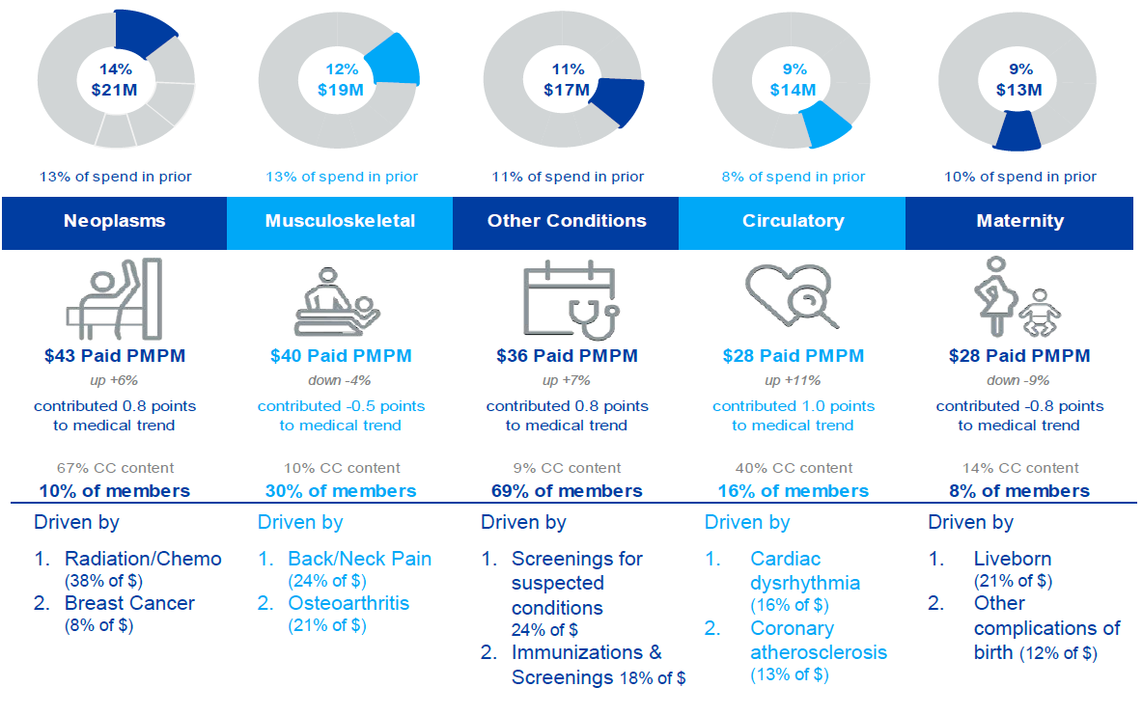

## KEY STEPS TO MANAGE PLAN COST

Steps taken in 2018 to manage plan costs for 2019 and succeeding years include the following:

* **Mizzou Specialty Pharmacy added to the network for the Columbia Custom Network Plan** - Specialty drugs are exclusively filled through Express Scripts Accredo Specialty Pharmacy for the PPO and Healthy Savings Plan. In 2018, we were able to expand the specialty drug network to include Mizzou Specialty Pharmacy for the Columbia Custom Network Plan members.   The estimated savings to the University is $600,000.
* **Real Appeal** a virtual and on-line weight loss program focused on diet, exercise, and peer support and coaching. The positive impact this program will have on members with circulatory concerns, diabetes, pre-diabetes and weight management is estimated to reduce cost drivers by $966,000.
* **Ortho Net Focused Claim Review** identifies coding errors not identified through automatic claims processing prior to payment. This service is estimated to save the University $48,000.
* **Arthroscopy Medical Necessity Bundle** for all medical plans. This is a process for determining if services, tests and procedures are clinically and cost effective. The estimated net savings after the cost of this service is $49,000.
* **Treat pregnancy and delivery as inpatient** to be consistent with other inpatient care copay. The estimated savings to the University is $600,000.
* **Increased copays by $5 for primary and specialist visits** for all medical plansas a cost shift from employer to employee. The estimated savings to the University is $1,600,000.
* **Increased out-of-pocket maximum** to meet 2019 IRS limits. The increased limits were applied to the pharmacy out-of-pocket maximum due to higher pharmacy cost trends. The estimated savings to the University is $1,500,000.

See attachment A for a side-by-side comparison of Summary Plan Document changes from 2018 to 2019.

# **PREMIUMS IMPLEMENTED IN 2019**

The University Of Missouri System Office Of Human Resources, in collaboration with TRAC, is continually identifying strategies to reduce costs and increase value in the benefit plans. Premiums continue to increase as medical cost trends continue to escalate, similar to trends across the industry.



Premiums listed are per month payments.

1. **RETIREMENT PLANS FINANCIAL IMPACT**

actuarial Report

Each year, the University completes an actuarial valuation report for the University of Missouri Retirement, Disability and Death Benefit Plan (the “RDD Plan”) which provides the required contribution for the upcoming fiscal year for this plan. The valuation is presented annually as an Information Item. A second core retirement plan, named the Employee Retirement Investment Plan (the “ERIP”), was developed in 2012. Employees hired by the University on or after October 1, 2012, are participants in the ERIP plan.

Participation over time will shift from a majority in the RDD Plan to the majority in the ERIP; therefore, the annual information item for the Board of Curators is expanded to provide an overall Annual Retirement Plan report, which includes the annual valuation for the RDD Plan. This approach provides broader information regarding the participation, performance and contributions to the University’s retirement plans. A copy of the valuation report has been included for review as an attachment.

REQUIRED CONTRIBUTION

The RDD Plan’s required contribution for FY20 is 11.18% of payroll compared to 11.13% for FY19. The FY20 required contribution is based on an assumed 7.20% investment return and a 30-year closed amortization period. The University funds 9.87% along with the employee contribution of 1.31%, meeting the 11.18% required contribution for FY20.

1. **RETIREMENT TRENDS**

The number of annual retirements has remained steady over the past several years, with a spike in 2017 due to changes in retiree health insurance eligibility, which became effective January 1, 2018.

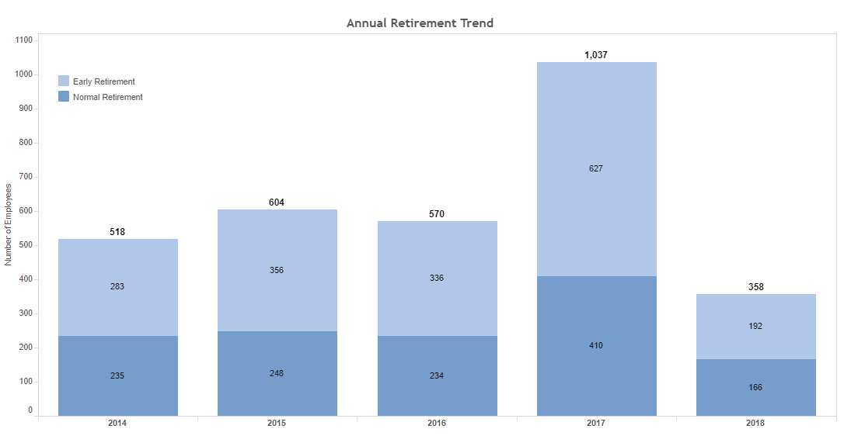

*2017 numbers include increased retirements due to retiree insurance changes effective January 1, 2018

Although the eligibility changes drove a record number of retirements in 2017, it is anticipated that the number of annual retirements will continue to climb over the next several years due to the University’s aging population. A total of 19.5% of the University’s population is currently eligible for retirement (4.5% normal retirement, 15% early retirement).

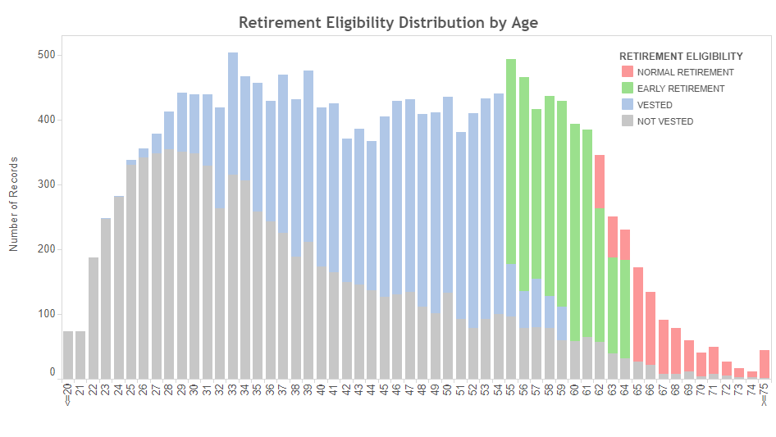

1. **STRATEGIC DIRECTION**

The University Of Missouri System Office Of Human Resources continues to engage TRAC, a critical stakeholder group from all campuses and MU Healthcare, to review our benefit and retirement offerings. Significant work is also being accomplished through partnerships and collaborations to assess the options and feasibility of potential plan design changes. In the near future, we are anticipating discussions and potential strategic directions in the following areas:

* **Potential benefit package enhancements -** We are reviewing the feasibility of adding Short-Term Disability as a voluntary benefit for employees. If added, the benefit would be paid by the employee. In coordination with Short-Term Disability, we are reviewing a Parental Leave Policy.
* **Life Insurance** – A review of market rates is being conducted to determine if improved options are available for life insurance carriers and rates for employees.
* **Premium Cost Share 5-Year Plan –** Continue analysis and implementation of 5-year plan, effective 1/1/19, to align premium cost sharing with actuarial equivalent amounts for active employee dependent coverage and for retirees.
* **Proposal of a new retirement plan for future employees –** In collaboration with TRAC, university leaders and advisory groups, and outside consultants, our office continues work to seek approval and implement a defined contribution plan for new employees hired on or after October 1, 2019.
* **Fidelity and TIAA fee review to ensure cost effective plans –** We have engaged Willis Towers Watson to complete a fee review of our defined contribution platforms to ensure that the fee structures for our current scope of services are competitive with current market conditions.

Thank you for the opportunity to provide this annual report. We look forward to continued improvements to ensure competitive and financially sustainable benefit and retirement programs for the University of Missouri System.

1. **ATTACHMENTS**
   * + 1. BENEFIT SUMMARY PLAN DOCUMENT CHANGE COMPARISON 18-19

|  |  |  |  |
| --- | --- | --- | --- |
| **­­­­­­Changes** | **2018** | **2019** | **Reason for Change** |
| Increase copays by $5 for primary and specialist visits | $5 for primary care; $25 for specialist | $10 for primary care; $30 for specialist | Shift in cost sharing to employee |
| Increase out-of-pocket maximum | Medical - $3,500/self-coverage; $7,000/family coverage  Prescription - $3,650/self-coverage; $7,300 /family coverage | Medical - $3,500/self-coverage; $7,000/family coverage  Prescription - $4,400/self-coverage; $8,800/family coverage | Changed to meet 2019 IRS limits. The increased limits were applied to pharmacy due to higher pharmacy cost trends. |
| Treat pregnancy and delivery as inpatient service in the Custom Network Plans | $25 copay for maternity delivery | $300 copay for maternity delivery | Changed to be consistent with other inpatient care copay |
| Removed Tobacco discount | $50/month premium discount for non-tobacco users | All employees are at the discounted premium level | 86% of employees consistently indicated tobacco-free for past two years. Reduced administration. |
| Annual Enrollment default | Default to Healthy Savings Plan if no election made during Annual Enrollment | Default to current medical enrollment if no election made during Annual Enrollment | Reduced administration |
| **­­­­­**Flex Spending Account contribution increase | IRS limit $2,600 | IRS limit $2,650 | Changed to meet 2019 IRS limits |
| Wellness incentive payout structure | Must complete Tier 1 by April 30 to receive $50 in May and be eligible to participate in Tier 2 $400 payout in October. | Cycle 1 and Cycle 2 are independent of each other. Complete Cycle 1 by April 30 to receive $225 in May. Complete Cycle 2 by September 30 to receive $225 in October. | Allow new hires after April 30 the opportunity to participate in the wellness program. |
| Increase premium factors for dependent coverage for active employees | Self – 1.00  Self + Spouse – 2.00  Self + Child(ren) – 1.71  Full Family – 2.82 | Self – 1.00  Self + Spouse – 2.04  Self + Child(ren) – 1.81  Full Family – 2.96 | To transition cost of dependent coverage to actuarial factor values. |
| Increase premium factors for dependent coverage for non-Medicare retirees | Self – 1.00  Self + Spouse – 2.00  Self + Child(ren) – 1.71  Full Family – 2.82 | Self – 1.00  Self + Spouse – 2.04  Self + Child(ren) – 1.81  Full Family – 2.96 | To transition cost of dependent coverage to actuarial factor values |

* + - 1. RETIREMENT, DISABILITY, AND DEATH BENEFIT PLAN ACTUARIAL REPORT

(see attachment)